Virtual Machine

1. Introduction

A Virtual Machine (VM) is a software-based emulation of a physical computer. It runs an operating system (OS) and applications just like a physical machine, but it is hosted on a physical server or a cloud-based environment.

VMs enable multiple OS environments to coexist on the same physical hardware in a completely isolated manner.

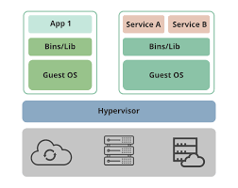

Virtual machine

**Types of virtual machines:**

there are two types of virtual machines: process VMs and system VMs.

* **Process VM:**A process VM, also called an application virtual machine or managed runtime environment (MRE), creates a virtual environment of an OS while an app or single process is running and destroys it as soon as you exit. Process VMs enable creating a platform-independent environment that lets an app or process run the same way on any platform.
* **System VM:**A system VM (sometimes called hardware virtual machines) simulates a complete operating system, allowing multiple OS environments to live on the same machine. Typically, this is the type of VM people are referring to when they talk about “virtual machines.” System VMs can run their own OS and applications, and a hypervisor monitors and distributes the physical host machine’s resources between system VMs.

2. Key Concepts

2.1 Hypervisor

A hypervisor (also known as a virtual machine monitor, VMM) is the software layer that enables virtualization. It separates the virtual machines from the hardware and manages them.

Types of hypervisors:

* Type 1 (Bare-metal) — Runs directly on hardware (e.g., VMware ESXi, Microsoft Hyper-V, Xen).
* Type 2 (Hosted) — Runs on top of a host OS (e.g., VirtualBox, VMware Workstation).

**2.2 Virtual Machine Components**

A typical VM consists of:

* **Virtual CPU (vCPU)**  
  Emulated processor.
* **Virtual Memory (RAM)**  
  Allocated portion of host RAM.
* **Virtual Storage**  
  Emulated hard disk (often a file on the host).
* **Virtual Network Interface (vNIC)**  
  Allows network connectivity.
* **Virtual BIOS/UEFI**  
  Emulates the system firmware.

3. How Virtual Machines Work

1. Physical hardware is abstracted by the hypervisor.
2. Each VM runs its own guest OS in isolation.
3. The hypervisor controls resource allocation to each VM.
4. The guest OS and applications behave as if running on physical hardware.

4. Benefits of Virtual Machines

* **Isolation**  
  Each VM runs separately and does not affect others.
* **Resource Optimization**  
  Multiple VMs share the same physical hardware, improving efficiency.
* **Portability**  
  VMs can be easily moved between servers or to the cloud.
* **Testing and Development**  
  Safe environments for testing new software or updates.
* **Disaster Recovery**  
  Simple to back up and restore VMs if needed.
* **Scalability**  
  Cloud-based VMs can quickly scale up or down based on demand.
* **Lower Costs**  
  Reduces hardware, power, and maintenance costs by running many VMs on one machine.
* **Faster Setup**  
  VMs can be quickly duplicated to create new environments.
* **Reliability**  
  If one VM fails, others and the host system remain unaffected.
* **Better Security**  
  Allows safe testing of apps or security experiments without risk to the host system.

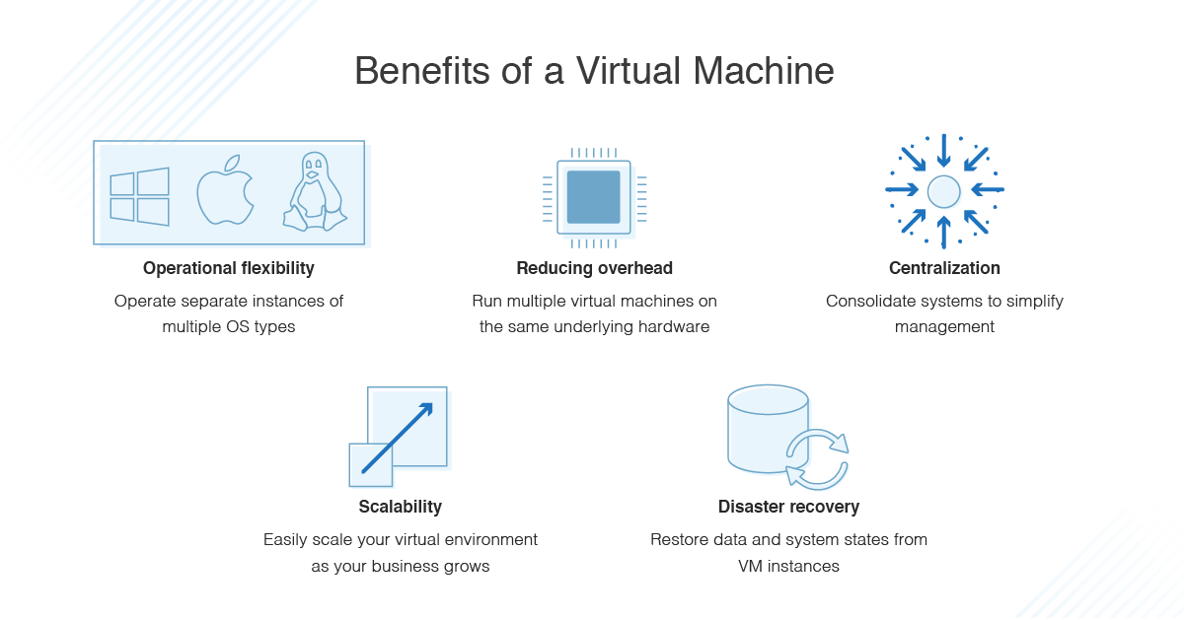

Benefits of Virtual Machine

5. Limitations of Virtual Machines

* Performance overhead: Some CPU/memory performance penalty compared to bare-metal.
* Resource contention: Improper allocation can cause performance issues.
* Complexity: Managing many VMs requires tools and expertise.

6. Virtual Machine vs Container

| **Feature** | **Virtual Machine** | **Container** |
| --- | --- | --- |
| Isolation | Full OS, hardware level | OS level (process level) |
| Size | Larger (includes OS) | Smaller (shares OS kernel) |
| Startup Time | Minutes | Seconds |
| Portability | High | Very High |

7. Common Use Cases

* Server consolidation
* Development and testing
* Running legacy applications
* Cloud computing (IaaS platforms like AWS EC2, Azure VMs, GCP Compute Engine)

Uses of Virtual Machine

Below are the uses of virtual machines:

1. Device Backup: Virtual machines provide file backups as they copy the existing programs and operating systems. The applications and settings that are being used on other devices can be backed up with the help of virtual machines. In case of any issue with the device, it helps to access the prior versions of the operating system or the applications.
2. Testing: Virtual machines are being used for the purpose of testing for many use cases such as the beta release of software can be copied for testing before releasing the final overall versions of the products to the customers. The test scripts can also be tested through the software and make sure that everything that is developed works accordingly.
3. Program Development: Virtual machines help to individually develop the programs. The developers can code the applications in a new environment with the help of virtual machines. The versions can be directly deployed to the cloud for other available users if the virtual machine has connections to the cloud server.
4. Cyber security: The host devices can be used to run the programs if the live devices have any security-related issues. It helps to protect the data and devices of the employees in the organizations. Virtual machines are being used by many cybersecurity professionals for inspecting existing cybersecurity-related issues.

8. Popular Virtual Machine Platforms

* VMware vSphere / ESXi
* Microsoft Hyper-V
* Oracle VirtualBox
* KVM (Kernel-based Virtual Machine)
* Xen Project

**Examples of Popular Virtual Machine Software**

1. **Parallels Desktop**  
   Allows Windows to run on Mac without rebooting. Fast, powerful, supports Windows, Linux, and MacOS. Easy switching between Mac and Windows.
2. **Citrix Hypervisor**  
   Simplifies managing virtual environments. Ideal for Windows 10. Offers secure file access and supports graphic-heavy workloads. Apps can be accessed from any device.
3. **Red Hat Virtualization**  
   Open-source platform for managing and creating VMs. Supports Windows and Linux. High performance for cloud and Kubernetes environments. Easy system integration.
4. **VMware Workstation Player**  
   Runs multiple OS on one machine. Allows data sharing between host and guest systems. Supports 64-bit Windows, Linux, CentOS, and Ubuntu. Business licenses available.